**Name** : Avinash  
**Roll** **number** : 21011102019

**Routing Implementation using ExpressJS**

server/index.js:

const http = require('http');

const express = require('express');

const bodyParser = require('body-parser');

// const server = http.createServer((req, res) => {

// res.writeHead(200, { 'Content-Type': 'text/plain' });

// res.end('Hello, Node.js Server!\n');

// });

const PORT = process.env.PORT || 3001;

const app = express();

app.use(bodyParser.json());

app.use(express.json());

app.use(express.urlencoded({ extended: false }));

app.get('/', (req, res) => {

res.send('this is root endpoint')

})

app.post('/', (req, res) => {

console.log(req.body)

res.send('POST request to the homepage')

})

app.listen(PORT, () => {

console.log(`Server is running on port ${PORT}`);

});

// server.listen(PORT, () => {

// console.log(`Server is running on port ${PORT}`);

// });

Output in Vs code terminal:

Output for GET in localhost:3001

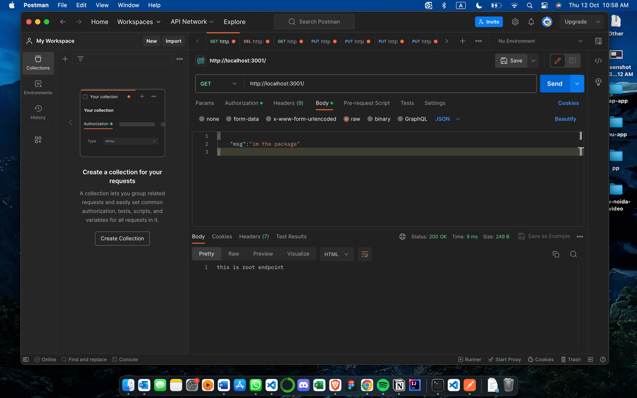

Output for POST in localhost:3001

